Student Worksheet 1

Aging of the population and pension

Date: ..............................

Name: ..............................

Aging of the population and old age pension - Changes in age-specific composition and pension

The figure depicts the human life curve and his economic activity from birth to death. Place the following stages on the figure: child, adolescent, worker, pensioner.

Study the figure and decide on the following:
- In which period of life is a person economically active and works for income?
- In which periods of life is a person economically inactive and depends more on others’ help?
- What is a pension?
- At what age can people in your country retire?
- Where does a country get the money to pay old age pensions?
- What are the main factors that affect the amount of money in the pension fund of a country?

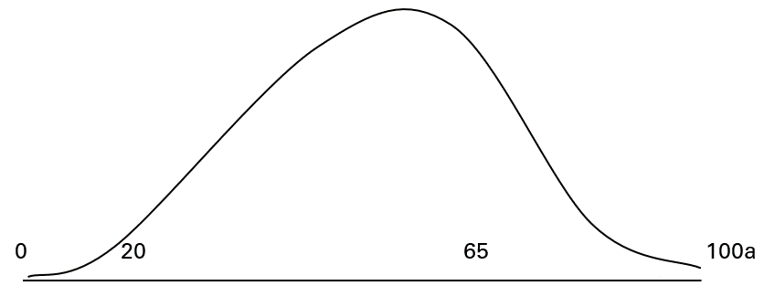

The number of people in employment depends on the overall number of citizens and their life expectancy i.e. the age-specific consistency of a nation. Population pyramids illustrate these trends.

Open the population pyramid of your country on the homepage of Population Pyramids of the World from 1950 to 2100, https://www.populationpyramid.net/
Find your age group on the pyramid. Deciding by the shape of the pyramid, are there many or few people compared to other age groups?

See how sizes and pyramid shapes of different age groups can change in time.
Choose year 2020 in the pyramid. Find the sizes of age groups of that particular year and write the results in the table below. Add the figures for 2040, your prime employment year. What is the ratio of age groups in 2060, right before you retire?

year | % of people aged under 20 | % of people aged 21–64 | % of people aged over 65 | Number of pensioners per 100 employed people  (VSM)
2020
2040
2060

Relying on the results in the table, draw conclusions about the ratio of different age groups and the number of pensioners.
How could these changes affect your pension in the future?

Student Worksheet 2

Aging of the population and pension

Date: ..............................

Name: ..............................

Young people and pension

Studies of age-specific composition of the population show that in the future the number of employed people is going to decrease in comparison to the present because in addition to the expected rise in life expectancy, less children are born. The ratio of old age pensioners is going to be considerably bigger in the decades than it is now. At the same time the number of employed people or tax payers is on the fall.

1. Using reliable sources find the following data about your country:
- How big is the average old age pension now?
- How big are the average wages?
- In comparison to a worker’s income, how big should a pension be in order to retain the same standard of living in retirement?

2. Answer the questions:
- How old do you think you will live to be?
- How many years will you live as a pensioner?
- How big is the monthly sum you need to retain the present living standard?

3. Old age pension system
Find out how the pension system of your country works.

4. Getting ready for an old age pension:
a) How could you prepare for an old age pension so that it would not come unexpected
financially?
b) Why is it wise to start collecting funds for the old age pension yourself?
c) Discuss with your classmates and write down some ways for securing your old age other
than starting pension funds.

Summary

Based on what was discussed in the class, what would you say to a 17-year-old friend who does not have an opinion about old age pension yet?

Home assignment

Discuss it with your family and find out how your parents have secured or plan to secure their and your future and retirement.

